**Weather Check**

**Site Plan Overview**

**Laura Lykins | CIT230**

**Site Name**

**The proposed name of this website is Weather Check. The domain name *weathercheckidaho.com* is available at a cost of $12/year. Including the state in the domain name narrows the scope to our more local weather offering. Motto: “Your Accurate Forecast. Now.”**

**Logo**



**Site Purpose**

**The purpose of Weather Check is to provide accurate and up-to-date weather information for our service area which includes Preston, Soda Springs and Fish Haven, Idaho. Current temperature, forecasts, maps and other relevant weather information will be easily accessible.**

**Target Audience**

**Who:** daily commuters, students, outdoor enthusiasts/vacationers

**Age:** 16 – 85

**Income:** aside from students, income range is $45,000+ annually

**Motivation:** the two main reasons for using the service is to check the weather for a daily commute/work plans and for planning trips or events that may include outdoor activities, especially in the Bear Lake area.

**Persona 1**



**Candice Zacharias**

**Occupation:** paralegal and mother of 4

**Demographics and Education:** 34 years old, Bachelors Degree in Criminal Justice. Annual income $52,000 (Combined family income $170,000).

**Social:** involved with her children’s school and sports activities. Likes camping, boating, and other outdoor activities with her family.

**Site interest:** has a daily 30-minute commute for work, drives her kids to their soccer and baseball games, weekend family excursions, many to Bear Lake.

**Technology:** has a laptop for work, but mainly uses smart phone. outside of work.

**Persona 2**



**Matt Mortensen**

**Occupation:** Construction Manager

**Demographics and Education:** 26 years old, Associate Degree in Business. Annual income $48,000 with potential for growth.

**Social:** weekend hiking/camping enthusiast. Has friends with like interests.

**Site interest:** Commute varies, has crews working outside year-round within the weather coverage area. Summer weekends often spent at Bear Lake.

**Technology:** uses a tablet and laptop for work. Carries a smart phone.

**Scenarios**

The website should address the following concerns/scenarios that a user might have as they go about their day and plan for both work and leisure. Current local conditions and forecasts are available as well as a storm center for tracking inclement weather.

* What will the road conditions be for my commute?
* Will the soccer game be cancelled?
* What is the forecast for boating conditions at Bear Lake this weekend?
* Will there be a school delay or cancellation?
* Will the weather be good for the next few days?
* What should I wear today?

### Color Palette

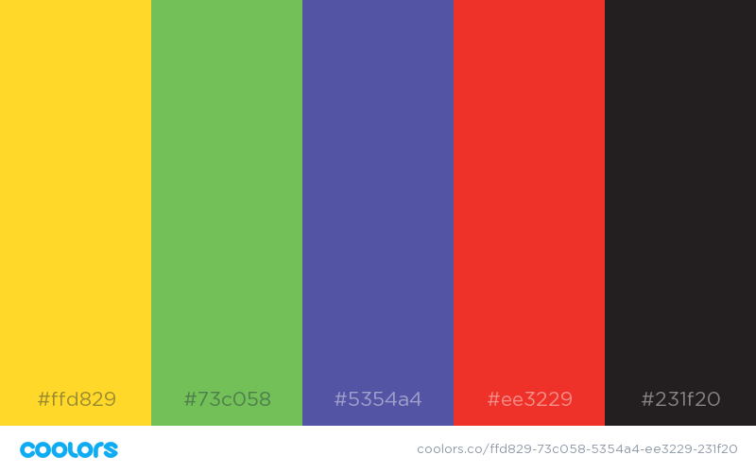

|  |  |  |  |  |
| --- | --- | --- | --- | --- |
| **Secondary** | **Primary** | **Accent** | **Accent** | **Accent** |
| #3b4d75 | #e5de19 | #2b352b | #edeef2 | #872727 |

## Typography

### Body Copy

Font family: Lato

ABCDEFGHIJKLMNOPQRSTUVWXYZ

abcdefghijklmnopqrstuvwxyz

123456790!@#$%^&*()_+

ABCDEFGHIJKLMNOPQRSTUVWXYZ

abcdefghijklmnopqrstuvwxyz

123456790!@#$%^&*()_+

### Headings

Font family: Roboto Slab

Heading 1

Heading 2

Heading 3

## Layout

### Site Map

Home

Soda Springs

Preston

Storm Center

Fish Haven

Gallery